

Travlr Getaways Booking Site

CS 465 Project Software Design Document
Dalton Johnson
Version 1.0

Table of Contents

CS 465 Project Software Design Document 1
Table of Contents 2
Document Revision History 2
Instructions 2
Executive Summary 3
Design Constraints 3
System Architecture View 3
Component Diagram 3
Sequence Diagram 4
Class Diagram 4
API Endpoints 4
The User Interface 4

Document Revision History

Version | Date | Author | Comments
1.0 | 05/14/2026 | Dalton Johnson | Completed Executive summary, Design Constraints, and System Architecture View. Initial work put into Sequence Diagram which can be improved and built upon in later versions.
1.0 | 06/06/2026 | Dalton Johnson | Completed RESTful API controllers and routes
1.0 | 06/20/2026 | Dalton Johnson | Completed Security for the Application

Instructions

Fill in all bracketed information on page one (the cover page), in the Document Revision History table, and below each header. Under each header, remove the bracketed prompt and write your own paragraph response covering the indicated information.

Executive Summary

In this revision of the web application, I utilized routing, controllers, and partials to maintain scalability and application organization. In this iteration, the application is an Express web application with routes, controllers, views, and data models that interact with one another to complete home page to the satisfaction of the SDD. The customer facing side of the application closely resembles the wireframe, including a homepage with buttons linking to additional pages for travel, rooms, meals, news, and information about the company. At this point in development, there is not a system for the user or admin to login to an account. MEAN stack is utilized for ease of programming and reusability since all aspects use java script.

Design Constraints

Some design constraints for this application include the timeline for releasing a fully functional application at the requested date of release. Non-negotiables for this application include account creation functionality, login for existing accounts, search functions based on selected criteria, as well as the ability to book reservations with the company through the site. Stable website access is also required, as well as a backend admin access with functionalities to manage customer bases, trip packages, and alter item and package pricing.

System Architecture View

Component Diagram

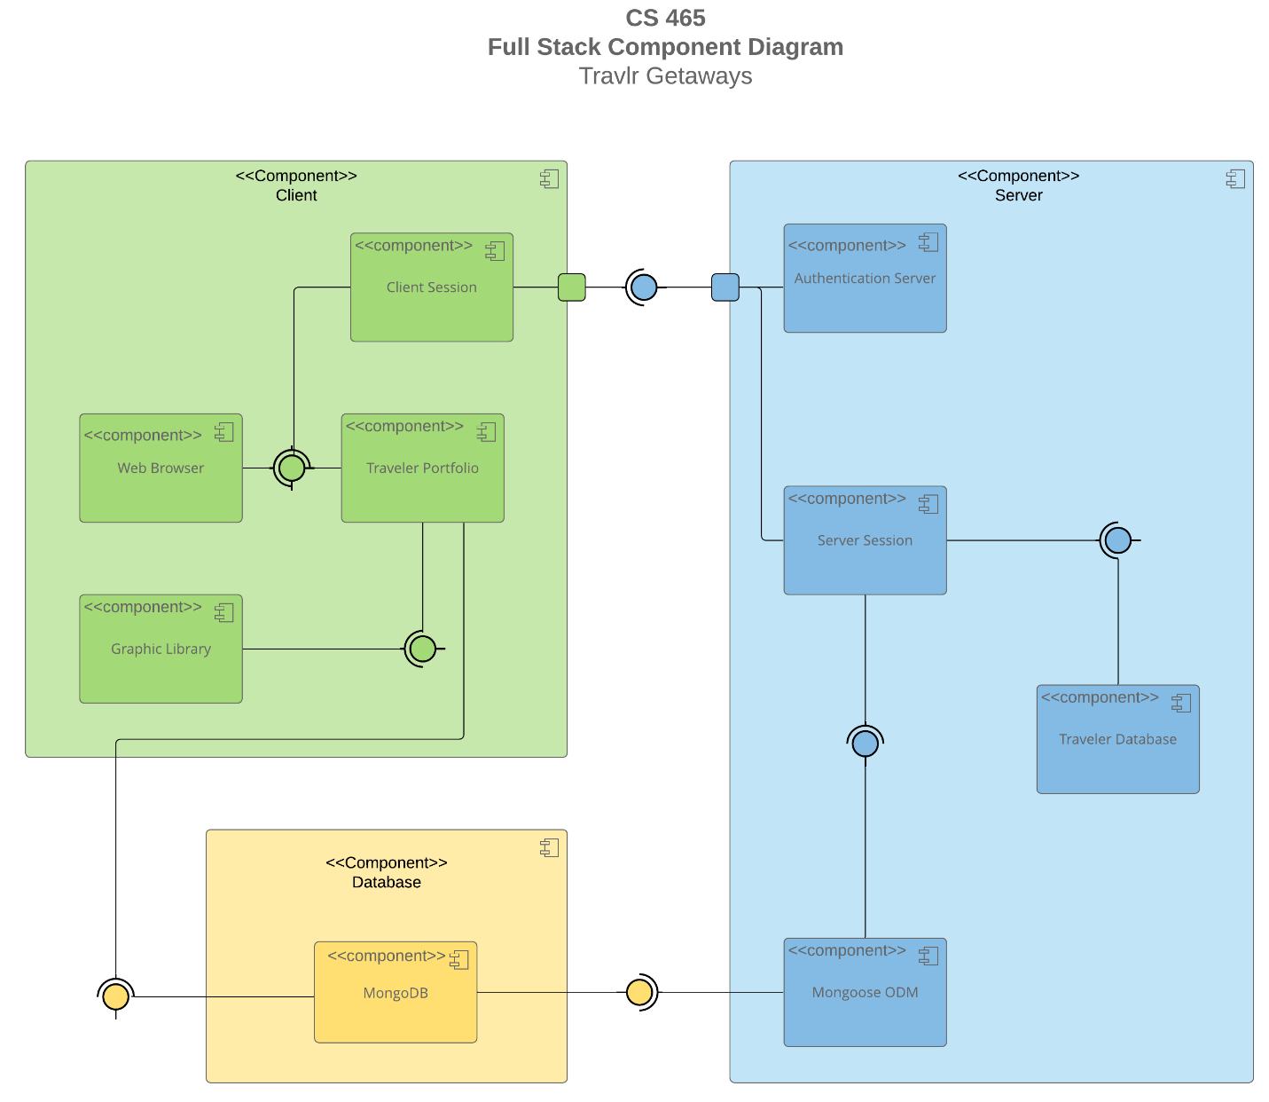

A text version of the component diagram is available: CS 465 Full Stack Component Diagram Text Version.

The system design is separated into three core components: the client , database, and server components. The client side contains sub-components which are referred to as the client session, web browser, traveler portfolio, and the graphic library. This will have all of the data that the client will directly interact with. The database functions using MongoDB, which will be the storage for all of the data for the web service. The Server component will include the authentication server, server session, traveler database, as well as Mongoose DDM. These will provide the back-end functionality of the webservice.

Sequence Diagram

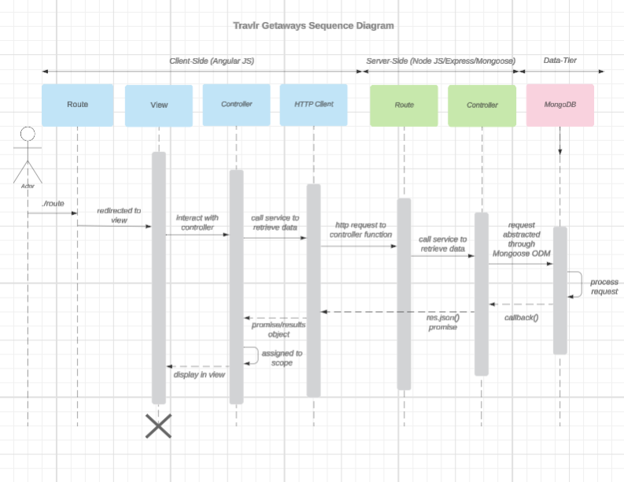

<Describe the flow of logic in the web application based on the sequence diagram. Be sure to describe the interactions between the layers, or tiers, of the full stack application. It will be helpful to include significant processes such as Sign In, Trips, and Admin interactions when referring to the sequence diagram.>

The user interacts with the router by searching for a specific page. The router then takes this request and forwards it to the View to display the page to the user, which can be interacted with to send additional requests. These additional requests are forwarded to the appropriate controller , which directs the request through the HTTP Client which will then send the request to the server-side of the application. In the server side of the application, the request is routed to a secondary set routes and controllers, which will finally retrieve the requested information from the database. Once the correct data is identified and retrieved, it is sent back through the controller so that it may be displayed through the view for the user.

An example of this sequence in function would be where a user searches the URL for the application, and is directed to the sign in page, where they login and enter the home page. While interacting with the home page, the user directs the application to the trips page, where clicking the trips button sends the request for the application to retrieve the page information for the trips from the database, and return it to the view. On the Administrative side of things, an administrator may interact with the trips page by updating a location or price-point. In doing so, they would make a request to update the information within the database, which will move through routes and controllers to do so, and then once updated the database will return the edited information to the view.

Class Diagram

<Illustrate the JavaScript classes of the web application by completing a class diagram for the web application. Insert an image of the class diagram here.>

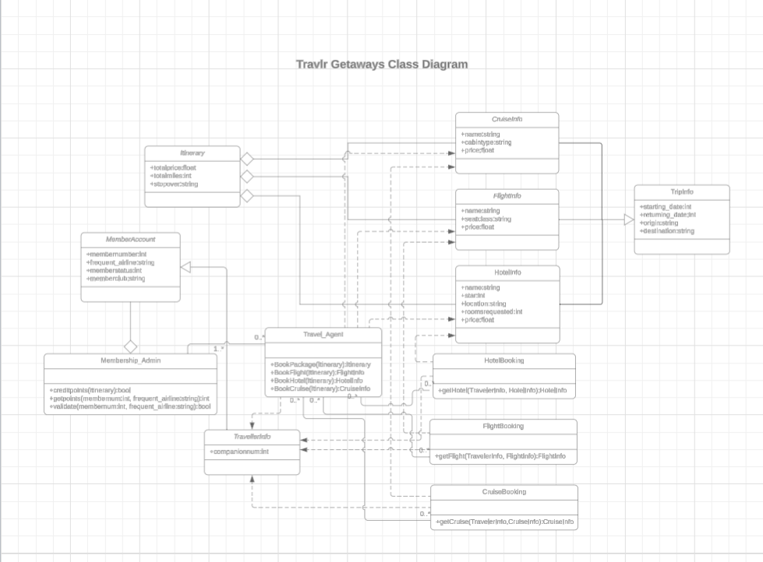
<Describe the JavaScript classes of the web application based on the class diagram.>

The Itinerary Class will contain information about the total price, total miles, and if there is a stop over. This will serve as a basic summary of the combined information from a selected trip. The Cruise/Flight/Hotel Info Classes each contain information about the respective attributes of a trip. Cruise contains descriptions of the cabin type and price information, Flight contains the seating class and price information, and the Hotel class contains information about the classification of the hotel, location information, number of rooms, as well as the price. TravellerInfo contains information about the user’s account, which is used with Membership related Classes. The TripInfo class includes information about the start and end dates of trips, as well as the destination and origin point of the trip.

The MembershipAccount class contains information about the user’s information, including their member number, membership status, membership club, and if they frequently fly via an airline. This class interacts with the Membership_Admin class as well as TravellerInfo. Membership_Admin is the administrative class for memberships, which allows for the interaction with credit points as well as validating membership information. The Booking Classes (including Hotel, Flight, and Cruise) function to obtain information about requested flights, hotels, or crusies. This information is sent to each respected Info class to aid in the requested information to book each aspect of the trip. The Travel_Agent class interacts with the other classes to enable it to book packages, flights, hotels, and cruises. Additionally, the Travel_Agent class is able to obtain information from the other classes to make these bookings.

Method | Purpose | URL | Notes
GET | Retrieve one trip by code | /api/trip/:tripcode | Returns a single trip from the database by using the designated trip code as a query filter
GET | Retrieve all trips | /api/trips | Returns all trips within the database
POST | Adds new trip | /trips | Adds a trip to the database (requires authentication)
PUT | Updates an existing trip | /trips/:tripcode | Edits a trip by finding the trip code (requires authentication)

The User Interface

(I unfortunately was unable to get my application to full functionality and understand that this will result in a deduction of points. I was unable to retrieve screenshots of the User Interface)

Angular structures differ from Express in that Angular specializes in the front end of an application, while Express is intended for the backend logic. When using angular, initial files within the structures will be loaded automatically for the user, while express will require specific requests to be made in order to retrieve files and data.

SPA (Single Page Application) functionality is beneficial when working with web applications due to its ability to eliminate the process of loading new pages when browsing, which provides a better user experience when interacting with the system. The operation of the system will be faster with this method, increasing efficiency and improving the user experience overall. To test SPA functionality, one must confirm that the data input when attempting to PUT data into the system. This can then be double checked by using a GET function to retrieve the data, and compare the input to the output. If the two do not match, then one or both methods has an error, which must then be debugged to solve the issue, which could either be a problem with storing the new information in the PUT function, or within the retrieval of the data in the GET function.

